*Study Protocol MIRAS IMU measurements*

|  |  |
| --- | --- |
| Date and time |  |
| Examiner |  |
| Subject |  |
| Comment |  |

**Materials:**

* Four Xsens MTw Awinda Motion Trackers (MTw’s) with Awinda station, a charger and a USB connecting cable for the Awinda station
  + Sensor IDs: 00B4489A, 00B448A1, 00B4496D, 00B44965 (with stickers 3,4,5,6)
  + Make sure the sensors are fully charged
* 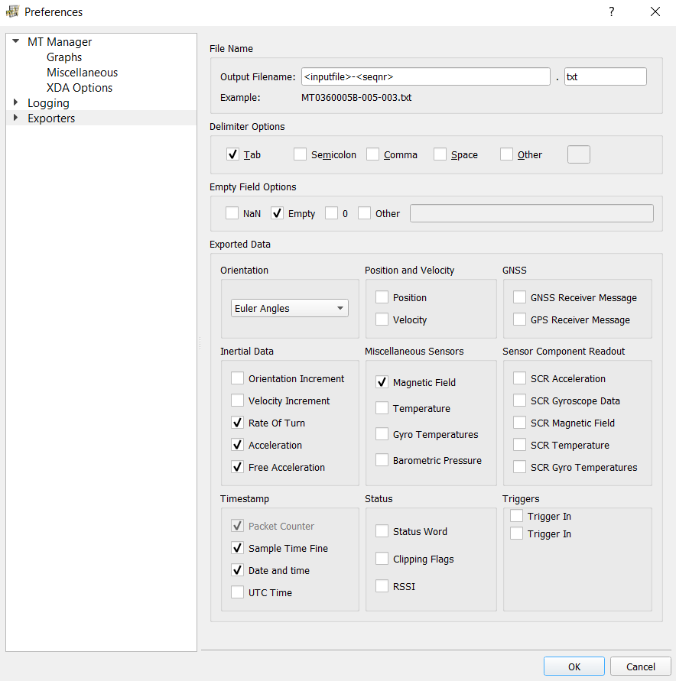A laptop, on which the Xsens MT Manager is installed, is connected via USB to the Awinda station

Figure : Export Preferences

* + Make sure to set the correct directory for storing the measurements
  + Set correct export preferences (Tools –> Preferences -> Exporters -> ASCII Exporter)
* Three MTw Velcro Body Straps (2x 5cmx29cm, 1x 10cmx128cm)
* One MTw Glove (Right handed)
* 9-hole PEG test (9-hole PEG board)
* Small container
* Box and Blocks test
* Stopwatch
* Chair and Table

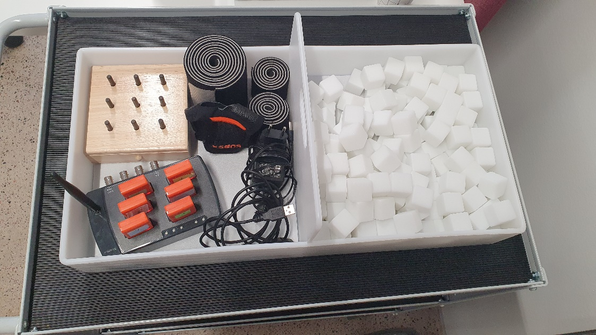

Figure : Equipment

**Introduction:**

* Thank subject for participation
* Explain IMU setup and briefly introduce to planned measurements
* Measurements can be interrupted or stopped anytime
* Give opportunity to ask questions

**Starting questions:**

### General:

|  |  |
| --- | --- |
| Do you feel rested? |  |
| How long have you had Ataxia/MIRAS? |  |
| Left or right-handed? |  |
| Gender |  |
| Age [years] |  |
| Weight [kg] |  |
| Height [m] |  |

### Questions on arm movements in general:

|  |  |
| --- | --- |
| What kind of regular activities do you do using your arm?  e.g. something like sports or workout |  |
| Did you do anything tiring in the past 2 days? |  |
| Are there arm movements with which you have particular difficulties in everyday life? |  |
| Are the difficulties more apparent in fine movements (e.g. writing, pushing a button...) or just as present in bigger movements (e.g. lifting a bag, throwing something) |  |
| Do you sometimes have difficulties reaching something or stretching your arm out? (Is the range of motion limited?) |  |

### Questions on the tasks planned in relation to Ataxia:

|  |  |
| --- | --- |
| One of the movements you will be doing is the nose-finger pointing task. Do you do something like this often? |  |
| Is it uncomfortable or tiring for you to do it? |  |
| In some tasks we will ask you perform a task as fast as possible. Do you do any type of speed tests with your hand often? |  |
| Is it uncomfortable or tiring for you to do it? |  |
| The tasks also involve picking up small items. Do you have any difficulties with that? |  |

**Sensor Setup**

Four sensors are used for the measurements.

|  |  |
| --- | --- |
| **Placement** | **Sensor ID** |
| Hand | 00B4496D |
| Wrist | 00B44965 |
| Upper arm | 00B448A1 |
| Back | 00B4489A |

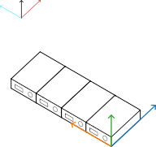First, connect the sensors to the station by enabling the wireless communication. If all sensors are found select the update rate as the standard update rate (100 Hz) and start the measurement. Calibrate the sensors by orienting them in the same direction and reset the heading for all devices. Warm up the Kalman filter by making slow and calm movements for about one minute. Wait until the orientation for all sensors is stable.

**Heading reset (10s)**

Figure : Heading reset

|  |  |
| --- | --- |
| Run ID |  |
| Comment |  |

Now the setup is completed, and the sensors can be used.

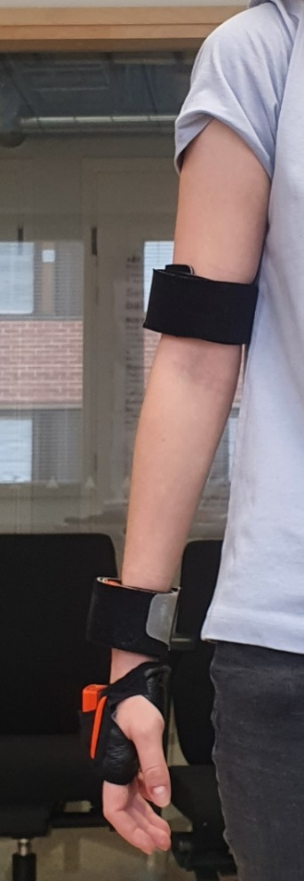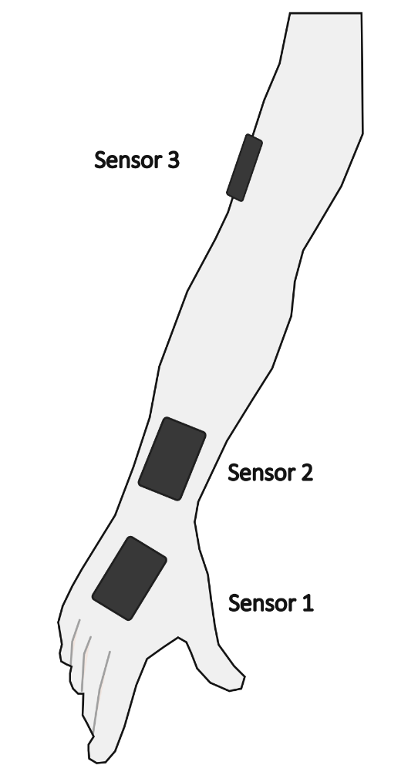The axes defined through the heading reset are kept as the global orientation frame and need to be considered in the following tasks.

**Sensor Placement:**

Sensor 1 is placed on the back of the hand using the glove.

Sensor 2 and sensor 3 are placed using the thin body straps according to recommendations of Höglund et al.[1] and the MTw Awinda handbook. The forearm sensor is placed at the distal part as close to the ulnar process as possible and the upper arm sensor laterally on the distal part of the arm (see figure 3). Sensor 4 is placed on the shoulder blade using the wider body strap. The x-axis of the sensors placed on the arm point to the hand of the subject and the x-axis of the sensor on the back points downwards as well.

The x-axis of the sensors on the arm and hand point along the distal axis of the arm. The x-axis of the back points to the ground.

Figure : Placement sensors 1-3

**Calibration**

For being able to obtain the correct orientation of the single body segments, the sensors need to be calibrated. Therefore, the subject performs the T-position (can be done standing or sitting). The arms are abducted at 90°. Figure 5 shows the orientation of the T-pose relative to the global orientation frame and also the sensor orientation in relation to the body segment. It is important to do perform the tasks and calibration in the same orientation relative to the global orientation frame for all subjects of the study because then the orientation data can be compared with each other. The calibration is done twice for at least ten seconds each.

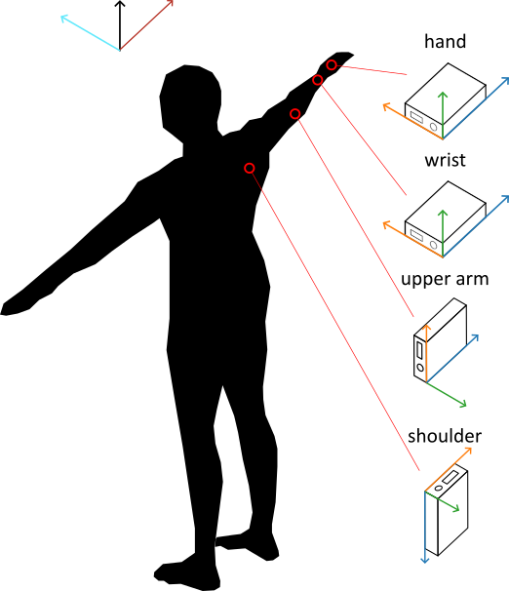

Figure : Calibration (x-axis: blue, y-axis: orange, z-axis: green)

**Calibration 1**

|  |  |
| --- | --- |
| Run ID |  |
| Comment |  |

**Calibration 2**

|  |  |
| --- | --- |
| Run ID |  |
| Comment |  |

**Data Collection**

The data collection can be started by clicking the red record button. The sensors should blink while measuring.

Make long enough breaks for resting between the single measurements.

**Pointing Task**

**Setup:**

* Target at eye level at about 90% of subject’s reach

**Instructions:**

* Movements are performed at moderate /own speed
* Subject is asked to point five times with his index finger from his nose to the target
* Task starts and ends with the index finger on the nose.
* 5 repetitions.

Show tasks.

* Questions?

|  |  |
| --- | --- |
| Comment: |  |

During the trials

* Rate on SARA scale for nose-finger-test:
  + 0 No tremor
  + 1 Tremor with an amplitude < 2 cm
  + 2 Tremor with an amplitude < 5 cm
  + 3 Tremor with an amplitude > 5 cm
  + 4 Unable to perform 5 pointing movements
* Note: how is the movement performed? Arm abducted? Pronation/Supination?
* Ask after trial: was it tiring? How did the patient perceive the task?

**Execution 1:**

|  |  |
| --- | --- |
| Rate on SARA Scale? |  |
| IMU Run ID |  |
| Comment |  |

**Execution 2:**

|  |  |
| --- | --- |
| Rate on SARA Scale? |  |
| IMU Run ID |  |
| Comment |  |

**Execution 3:**

|  |  |
| --- | --- |
| Rate on SARA Scale? |  |
| IMU Run ID |  |
| Comment |  |

**Execution 4:**

|  |  |
| --- | --- |
| Rate on SARA Scale? |  |
| IMU Run ID |  |
| Comment |  |

**Box and Blocks Test[2]**

**Setup:**

* subject is seated in front of test box with 150 blocks and a partition in the middle, which is placed lengthwise along the edge of the table
* 150 blocks are placed in the compartment of the test box of the patient’s dominant hand
* instructor faces the patient so that he/she can see the blocks being transported

**Instructions:**

**General:**

* how quickly can you pick up one block and carry it to the other side of the box and drop it there with one hand
* you have 60 seconds time
* fingertips should cross partitioning
* If multiple blocks are transported, they count as one
* Blocks on floor on table count as well, don’t pick it up!

Show it with 3 blocks.

* Practice for 15 seconds
* Give opportunity to ask questions

|  |  |
| --- | --- |
| Comment: |  |

**Practice Trial (15 s)**

* Start with hands places on the sides of the box.
* Start stopwatch: Ready, Go!
* Correct mistakes if any
* Check if IMU measured everything correctly

|  |  |
| --- | --- |
| Did subject make any mistakes? |  |
| IMU Run ID |  |
| Comment |  |

**Actual test (60 s)**

* Make aware that now the actual test starts
* Start with hands on the sides of the box.
* Start stopwatch: Ready, Go!
* Two executions

**Execution 1:**

|  |  |
| --- | --- |
| Number of Blocks Transported |  |
| IMU Run ID |  |
| Comment |  |

**Execution 2:**

|  |  |
| --- | --- |
| Number of Blocks Transported |  |
| IMU Run ID |  |
| Comment |  |

**9-hole PEG Test[3]**

**Setup:**

* 9-hole PEG test is placed in front of the subject
* Container holding the pegs is on the side of dominant hand

**Instructions:**

**General:**

* how quickly can you put all the pegs into the holes in any order, then remove the pegs and put them back in the container
* time will be measured
* only one peg at a time
* subject can stabilize the board with the other hand

Show it.

* Subject has one practice trial
* Give opportunity to ask questions

|  |  |
| --- | --- |
| Comment: |  |

**Practice Trial:**

* Start IMU measurement
* Start stopwatch when first peg is touched
* Stop when last peg hits container
* Correct mistakes if any
* Check if IMU measured everything correctly

|  |  |
| --- | --- |
| Did subject make any mistakes? |  |
| IMU Run ID |  |
| Comment |  |

**Actual Measurement:**

* Make aware that now the actual test starts
* Start IMU measurement
* Start stopwatch when first peg is touched
* Encourage Subject
* Stop when last peg hits container
* Two executions

**Execution 1:**

|  |  |
| --- | --- |
| Time |  |
| IMU Run ID |  |
| Comment |  |

**Execution 2:**

|  |  |
| --- | --- |
| Time |  |
| IMU Run ID |  |
| Comment |  |

**Pointing Task (again)**

**Setup:**

* Target at eye level at about 90% of subject’s reach

**Instructions:**

* Movements are performed at moderate /own speed
* Subject is asked to point five times with his index finger from his nose to the target
* Task starts and ends with the index finger on the nose.
* 5 repetitions.

Show tasks.

* Questions?

|  |  |
| --- | --- |
| Comment: |  |

During the trials

* Rate on SARA scale for nose-finger-test:
  + 0 No tremor
  + 1 Tremor with an amplitude < 2 cm
  + 2 Tremor with an amplitude < 5 cm
  + 3 Tremor with an amplitude > 5 cm
  + 4 Unable to perform 5 pointing movements
* Note: how is the movement performed? Arm abducted? Pronation/Supination?
* Ask after trial: was it tiring? How did the patient perceive the task?

**Execution 5:**

|  |  |
| --- | --- |
| Rate on SARA Scale? |  |
| IMU Run ID |  |
| Comment |  |

**Execution 6:**

|  |  |
| --- | --- |
| Rate on SARA Scale? |  |
| IMU Run ID |  |
| Comment |  |

**Execution 7:**

|  |  |
| --- | --- |
| Rate on SARA Scale? |  |
| IMU Run ID |  |
| Comment |  |

**Execution 8:**

|  |  |
| --- | --- |
| Rate on SARA Scale? |  |
| IMU Run ID |  |
| Comment |  |

**Again measure orientation of sensors**

**Orientation**

|  |  |
| --- | --- |
| Run ID |  |
| Comment |  |

**Review (after subject is gone):**

**Missing Data**

Check which data was not recorded correctly

|  |  |  |
| --- | --- | --- |
| **Task** | **Run number** | **Comment** |
|  |  |  |
|  |  |  |
|  |  |  |
|  |  |  |
|  |  |  |
|  |  |  |

**General Comments:**

1. G. Höglund, H. Grip and F. Öhberg, "The importance of inertial measurement unit placement in assessing upper limb motion" Medical Engineering & Physics, vol. 92 2021.
2. <https://www.sralab.org/sites/default/files/2017-06/Box%20and%20Blocks%20Test%20Instructions.pdf>, accessed 22.09.2022
3. <https://www.sralab.org/sites/default/files/2017-07/Nine%20Hole%20Peg%20Test%20Instructions.pdf>, accessed 22.09.2022